https://www.openglobalrights.org/global-solution-to-global-refugee-crisis/

A global solution to a global refugee crisis
If implemented as intended, the UN Refugee Convention points the way to a truly global solution to the refugee crisis.
James C. Hathaway
February 29, 2016

Share Facebook Twitter LinkedIn Email Print
TOPICS: Global, The Future of Refugee Protection, Global, The Future of Refugee Protection
The UN’s Refugee Convention is increasingly marginal to the way in which refugee protection happens around the world. I believe that this is a bad thing—both for refugees and for states.
When introducing the draft of the Refugee Convention some 65 years ago, the UN’s first Secretary General explained that “[t]his phase... will be characterized by the fact that the refugees will lead an independent life in the countries which have given them shelter. With the exception of the ‘hard core’ cases, the refugees will no longer be maintained by an international organization as they are at present. They will be integrated in the economic system of the countries of asylum and will themselves provide for their own needs and for those of their families.”
Yet today, and despite the fact that 148 countries have signed onto the Refugee Convention, the reality is quite the opposite. Most refugees today are not allowed to live independent lives. Most refugees are maintained by an international organization. And most refugees are emphatically not allowed to provide for their own needs.
Most refugees today do not enjoy the freedom of movement to which they are entitled under international law. In an especially cruel irony, the UN’s refugee agency—the United Nations High Commissioner for Refugees (UNHCR)—runs more refugee camps than anyone else. Not only is this response unlawful, it is absurdly counter-productive. Refugees become burdens on their hosts and the international community, and they are debilitated in ways that often make it difficult for them ever to return home, integrate locally or resettle. The risk of violence in refugee camps is also endemic—with women and children especially vulnerable to the anger that too often arises from being caged up.
What went wrong?
One thing that is not wrong is the Refugee Convention itself. Its definition of a refugee (“a well-founded fear of being persecuted” for discriminatory reasons) has proved wonderfully flexible, identifying new groups of fundamentally disfranchised persons unable to benefit from human rights protection in their own countries.
At least as important, its catalog of refugee-specific rights remains as valuable today as ever. The underlying theory of the Refugee Convention is emphatically not the creation of dependency by hand-outs. It guarantees the social and economic rights that refugees need to be able to get back on their feet after being forced away from their own national community—for example, to access education, to seek work and to start businesses. And as was patently obvious to the states that drafted the refugee treaty, refugees could not begin to look after themselves, much less to contribute to the well-being of their host communities, if they were caged up.
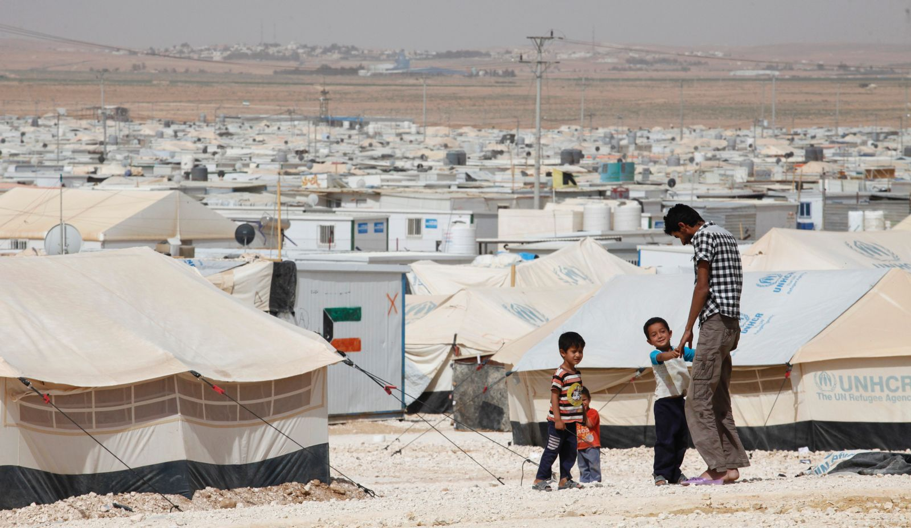
Flickr/World Bank Photo Collection (Some rights reserved)
Operated by UNHCR, the Zataari Refugee camp in Jordan houses nearly 80,000 Syrian refugees.

For this reason, as soon as a refugee has submitted herself to the jurisdiction of the host country, satisfied authorities of her identity and addressed any security-related concerns, the Refugee Convention requires that she be afforded not only freedom of movement, but the right to choose her place of residence—a right that continues until and unless the substance of her refugee claim is negatively determined. Indeed, a recent study shows that those countries that do facilitate refugee freedom of movement are often economically advantaged by the presence of refugees.
Why, then, are so many refugees subject to constraints on freedom of movement? Part of the reason is that setting up refugee camps is an easy “one size fits all” answer that can be quickly and efficiently rolled out by both the UNHCR and many of its humanitarian partners. When there is a political imperative to act, the establishment of camps is a concrete and visible sign of engagement. Indeed, even as the rest of the world largely ignored the regional states receiving most Syrian refugees, international donors stepped forward to finance the building and operation of refugee camps.
Most fundamentally, though, denying mobility rights to refugees is a strategy that appeals to states that would prefer to avoid their international duty to protect refugees. While not willing to accept the political cost of formally renouncing the treaty, states with the economic and practical wherewithal have for many years sought to ensure that refugees never arrive at their jurisdiction, at which point duties inhere. Deterrent practices have, however, been increasingly and successfully challenged in courts. Of course, poorer states, as well as those with especially porous borders, have rarely been able to deter refugee arrivals at all. In this context, refugee detention—often accompanied by other harsh treatment post-arrival—is seen as a second-best means for a state to “send a signal” that they are not open to the arrival of refugees.
But why are states so often unwilling to receive refugees? Safety and security are of course frequently invoked. While such concerns can be real, there is no empirical evidence that refugees present a greater threat of crime or violence than do the many other non-citizens routinely crossing borders, or indeed those already resident in the state—including citizens. In any event, the Refugee Convention takes a very hard line on such cases, requiring the exclusion from refugee status of any person reasonably suspected of being a criminal, and allowing states to send away those shown to pose a threat to their safety or security—even back to the country of persecution if there is no other option.
Most governments believe that refugees who arrive at their borders impose unconditional and indefinite obligations on them—and on them alone.
The real concern is instead that most governments believe that refugees who arrive at their borders impose unconditional and indefinite obligations on them—and on them alone. The idea that the arrival of refugees can effectively subvert a state’s sovereign authority over immigration is understandably unsettling to even powerful states. For states of the less developed world, which receive more than 80% of the world’s refugees, the challenge can be acute. They are supported by no more than the (often grossly inadequate and inevitably fluctuating) charity of wealthier countries, and rarely benefit from meaningful support to lessen the human responsibility of protection. Of the roughly 14 million refugees in the world last year, only about 100,000 were resettled—with just two countries, the United States and Canada, providing the lion’s share of this woefully inadequate contribution.
The challenge, then, is to ensure that refugees can access meaningful protection in a way that both addresses the legitimate concerns of states and which harnesses the refugees’ own ability to contribute to the viability of the protection regime.
The irony is that the Refugee Convention itself suggests the way forward. It rejects a charity-based model in favor of refugee empowerment. It is massively attentive to the safety and security concerns of states. It does not require the permanent admission of refugees, but only their protection for the duration of the risk in their home country. And perhaps most important, the refugee regime was never intended to operate in the atomized and uncoordinated way that has characterized most of its nearly 65-year history. To the contrary, the Preamble to the Refugee Convention expressly recognizes that “the grant of asylum may place unduly heavy burdens on certain countries”, such that real global protection “cannot therefore be achieved without international co-operation.”
This is not just another tired call for states to live up to what they have signed onto. It is rather a plea for us fundamentally to change the way that refugee law is implemented. The obligations are right, but the mechanisms for implementing those obligations are flawed in ways that too often lead states to act against their own values and interests—and which produce needless suffering amongst refugees.
How should we proceed?
A team of lawyers, social scientists, non-governmental activists, and governmental and intergovernmental officials, drawn from all parts of the world, worked for five years to conceive the model for a new approach to implementing the Refugee Convention. We reached consensus on a number of core principles.

1. Reform must address the circumstances of all states, not just the powerful few.
Most refugee “reform” efforts in recent years have been designed and controlled by powerful states—for example, Australia and the EU. There has been no effort to share out fairly in a binding way the much greater burdens and responsibilities of the less developed world, even at the level of financial contributions or guaranteed resettlement opportunities. This condemns poorer states and the 80% of refugees who live in them to mercurial and normally inadequate support—leading often to failure to respect refugee rights. It is also decidedly short-sighted in that the absence of meaningful protection options nearer to home is a significant driver of efforts to find extra-regional asylum, often playing into the strategies of smugglers and traffickers.

2. Plan for, rather than simply react to, refugee movements.
The international refugee system should commit itself to pre-determined burden (financial) sharing and responsibility (human) sharing quotas. Such factors as prior contributions to refugee protection, per capita GDP, and arable land provide sensible starting points for the allocation of shares of the financial and human dimensions of protection. But, as the recent abortive effort to come up with such shares ex post by the European Union makes clear, the insurance-based logic of standing allocations can only be accomplished in advance of any particular refugee movement.

3. Embrace common but differentiated state responsibility.
There need be no necessary connection between the place where a refugee arrives and the state in which protection for duration of risk will occur, thus undercutting the logic of disguised economic migration via the refugee procedure. And rather than asking all states to take on the same protection roles, we should harness the ability and willingness of different states to assist in different ways. The core of the renewed protection regime should be common but differentiated responsibility, meaning that beyond the common duty to provide first asylum, states could assume a range of protection roles within their responsibility-sharing quota (protection for duration of risk; exceptional immediate permanent integration; residual resettlement)—though all states would be required to make contributions to both (financial) burden-sharing and (human) responsibility-sharing, with no trade-offs between the two.

4. Shift away from national, and towards international, administration of refugee protection.
We advocate a revitalized UNHCR to administer quotas, with authority to allocate funds and refugees based on respect for legal norms; and encouragement of a shift to common international refugee status determination system and group prima facie assessment to reduce processing costs, thereby freeing up funds for real and dependable support to front-line receiving countries—including start-up funds for economic development that links refugees to their host communities, and which facilitate their eventual return home. Our economists suggest that reallocation of the funds now spent on domestic asylum systems would more than suffice to fund this system. And since as described below positive refugee status recognition would have no domestic immigration consequence for the state in which status assessment occurs, this savings could be realized without engaging sovereignty concerns.

5. Protection for duration of risk, not necessarily permanent immigration.
We should be clear that this is a system for which migration is the means to protection, not an end in and of itself. Managed entry regimes should be promoted where feasible, though the right of refugees to arrive wherever they can reach without penalization for unlawful presence must be respected (thus undercutting the market for smugglers and traffickers). Some refugees—such as unaccompanied minors and victims of severe trauma—will require immediate permanent integration, though others should instead be granted rights-regarding protection for duration of risk. Creative development assistance linking refugees to host communities would increase the prospects for local integration, and many refugees will eventually feel able to return home. But for those still without access to either of these solutions at 5-7 years after arrival, residual resettlement would be guaranteed to those still at risk, enabling them to remake their lives with a guarantee of durable rights—in stark contrast to the present norm of often indefinite uncertainty.
If we are serious about avoiding continuing humanitarian tragedy—not just in Europe but throughout the world—then the present atomized and haphazard approach to refugee protection must end. The moment has come not to renegotiate the Refugee Convention, but rather at long last to operationalize that treaty in a way that works dependably, and fairly.

ABOUT THE AUTHOR
James C. Hathaway
James C. Hathaway is Director of the Refugee and Asylum Law Program at the University of Michigan. He is also the distinguished Visiting Professor of International Refugee Law, at the University of Amsterdam. You can find him on twitter @JC_Hathaway.

