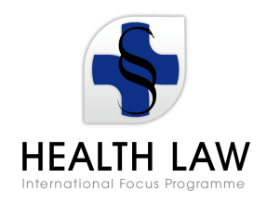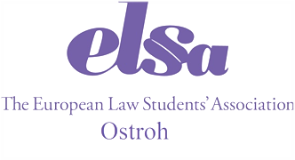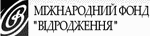

AGENDA
International Seminar on Human Rights in patient Care

Friday
25/05/2012
8.00-12.00 | Arrival of the participants
12.00-12:45 | Opening Plenary
12.45-15.00 | Lecture  (Medical law and ethics: general characteristics of national development vectors. Iryna Senyuta, candidate of law, associate professor, lawyer, president of the All-Ukrainian NGO “Foundation of Medical Law and Bioethics of Ukraine”)
15.00-15.20  15.20-17.50  18.00-19.00  21.00-22.00 | Coffee Break  Lecture  (Legal status of medico-legal relations under the legislation of Ukraine. Iryna Senyuta, candidate of law, associate professor, lawyer, president of the All-Ukrainian NGO “Foundation of Medical Law and Bioethics of Ukraine”)  Dinner  Rest hour

Saturday
26/05/2012
9.00-9.40 | Breakfast
10.00-12.00 | Lecture  (Practice of the European Court of Human Rights on medical cases. Aigul Mukhanova, legal expert of Kharkiv Human Rights Protection Group)
12.00-12.15 | Coffe Break
12.15-13.30 | Lecture  (Medical Insurance: some aspects of establishment and development in Ukraine. Alyona Romanova, lawyer of the Crimean republican charity fund “Crimean World”)
13.30-14.30  14.30-16.00  16.00-16.15  16.15-17.45  18.30-19.30 | Lunch  Lecture  (Offices of patient’s rights in Turkish hospitals. Hakan Hakeri, prof. Dr. jur. Dr. h.c., dean of the Law School of Istanbul Medeniyet University)  Coffee Break  Lecture  (Preparation of the material for the expertise in medical cases. Nicolai Tagaev, prof. of the department of criminal Law of Kharkiv National University of V.N Karazin, PhD, associate professor, forensic expert of the highest qualification category.)  Dinner

Sunday
27/05/2012
9.00-9.40 | Breakfast
10.00-12.00 | Lecture  (Patient’s rights and vaccination. Evgeniy Novitskiy, representative of the Crimean republican charity fund “Crimean World”, head of the law enforcement program in the sphere of medical law)
12.00-12.20 | Coffee Break
12.20-13.30 | Lecture  (Illicit drugs trafficing. Antony Kassamali, lawyer)
13.30- 14:30  14.30 – 16:00  16.30 - ……... | Lunch  Lecture  (Forensic evaluation of the traces to obtain confessions. Nicolai Tagaev, prof. of the department of criminal law of Kharkiv National University of V.N Karazin, PhD, associate professor, forensic expert of the highest qualification category).  Sightseeing and a free time

Monday
28/05/2012
9.00 – 9.40 |  | Breakfast
10.00 – 12. 00 |  | Lecture  (Human rights in the sphere of palliative care. Andiy Rohanskyy, head of public organization "Institute for Legal Studies and Strategies", lawyer, physician, MD)
12.00 – 12.20 |  | Coffee break
12.20-14.00 |  | Lecture  (Intellectual property rights in the sphere of medicine and pharmacy. Oksana Kashyntseva, candidate of law, head of the scientific laboratory of medical law and law of bioethics, Kyiv University of Law of the NAS of Ukraine)
14.00 – 15.00 | Dinner
15.00- 17.30 | Work in groups
Tuesday
29/05/2012
- BBQ
- Sightseeing at the regional capital – Rivne
- Departure of the participants

